Employee Accounts

Festival Advance

S.No. 01-FI-AP-12

Step 1: Acceptance of Advance

Post Vendor Down Payments

TRANSACTION CODE : F – 48

ACCESS PATH :SAP Easy Access Accounting Financial
Accounting Accounts Payable Document Entry
Down payment Down Payment

We get “ Post Vendor Down Payment” Header data” screen;

Required Fields:

Document date : To be entered
Account : To be entered (Vendor A/c Number)
Spl. G/L Ind. : To be set at “3” (Festival Advance to Staff)
Post date : Default
Amount : Total amount inclusive Bank Charges to be entered
Bank Charges : To be entered

Rest all other fields viz, Doc Type, Period, Companycode,Currency/Rate are default after they are entered for the first time.

We get the Screen “Post Vendor Down Payment - Header Data“ incorporating the above mentioned required fields as under;

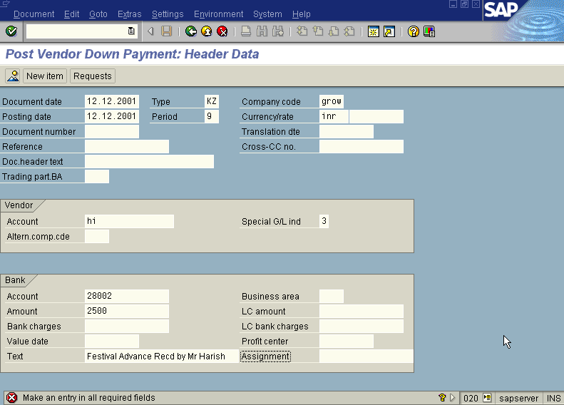

Press Enter button

Now we get the screen “ Post Vendor Down payment – Add Vendor Item” .

In this screen fill three fields –
- Amount (exclusive of bank charges )
- Text

Press Enter button

We will be presented with “ Post Vendor Down payment – Correct Vendor Item”
Screen.

The screen will appear as under.

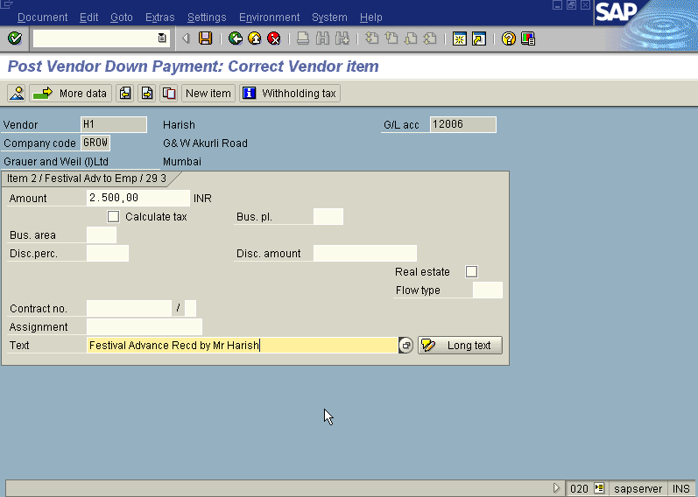
Press Enter button

Press Save button

The system will display a message as under

Take a note of the document number ; 1500223.

The document can be seen from Document Display from the top left hand side of the main screen “post Vendor down payment - Header Data“ OR from Transaction code FB- 03 .The Document overview screen will be displayed as under showing the entries.

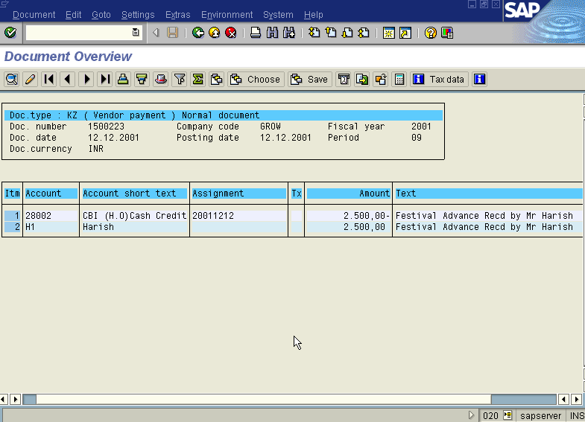

Step 2: Repayment of Festival Advance

Post Incoming Payments

TRANSACTION CODE : F – 52

ACCESS PATH :SAP Easy Access → Accounting → Financial
Accounting → Accounts Payable → Document Entry → Other → Incoming payment

We get “ Post Incoming Payment” Header data” screen;

Required Fields:

Document date : To be entered
Post date : Default
Account : To be entered (Bank G/L A/c Number)
Amount : Total amount inclusive Bank Charges to be entered
Account : To be entered (Vendor A/c Number)

Rest all other fields viz, Doc Type (KZ), Period, Company code, Currency/Rate, Account Type (K) are default after they are entered for the first time.

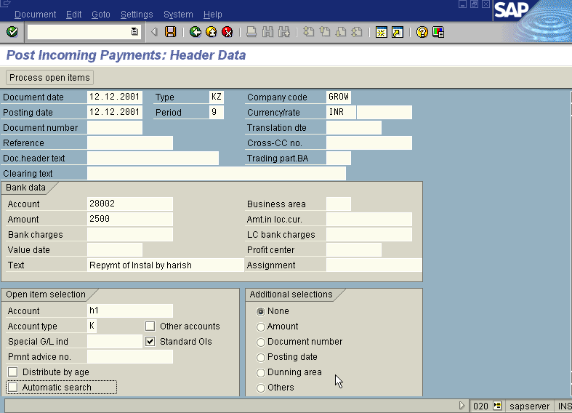

Press Process Open Item Button

We get “ Post Incoming Payment – Select Open Item” Screen as under

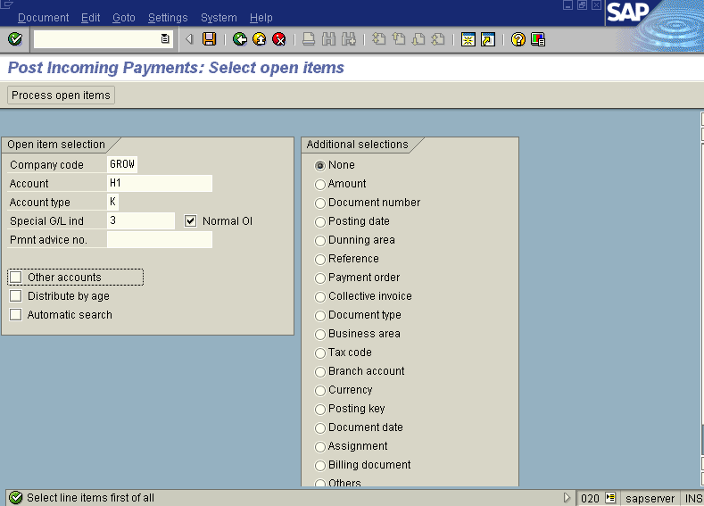
Press Process Open Item Button

We get “Post Incoming Payment – Process Open Item” Screen

In the above-mentioned Screen select the relevant document number and double click on its amount column. Lastly see that the Not Assigned portion is zero.

Press Save

Take note of the document Number: eg: 1500224

Note: Incase if the amount has to be refunded in Installments repeat the above process no of times till the entire amount is cleared.

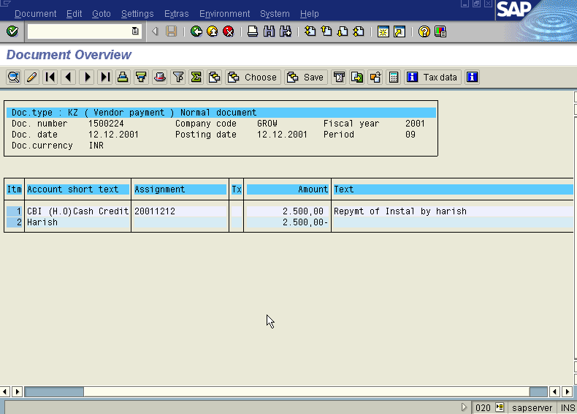
The document can be seen from Document →Display from the top left hand side of the main screen “post Incoming payment - Header Data“ OR from Transaction code FB- 03 .The Document overview screen will be displayed as under showing the entries.

Loan to Staff

Step 1: Advanced Staff Loan to Employee

Post Vendor Down Payments

TRANSACTION CODE : F – 48

ACCESS PATH :SAP Easy Access → Accounting → Financial
Accounting → Accounts Payable → Document Entry
→ Down payment → Down Payment

We get “ Post Vendor Down Payment” Header data” screen;

Required Fields:

Document date : To be entered
Account : To be entered (Vendor A/c Number)
Spl. G/L Ind. : To be set at “4” (Loan to Staff)
Post date : Default
Amount : Total amount to be entered
Bank Charges : To be entered

Rest all other fields viz, Doc Type, Period, Companycode,Currency/Rate are default after they are entered for the first time.

We get the Screen “Post Vendor Down Payment - Header Data“ incorporating the above mentioned required fields as under;

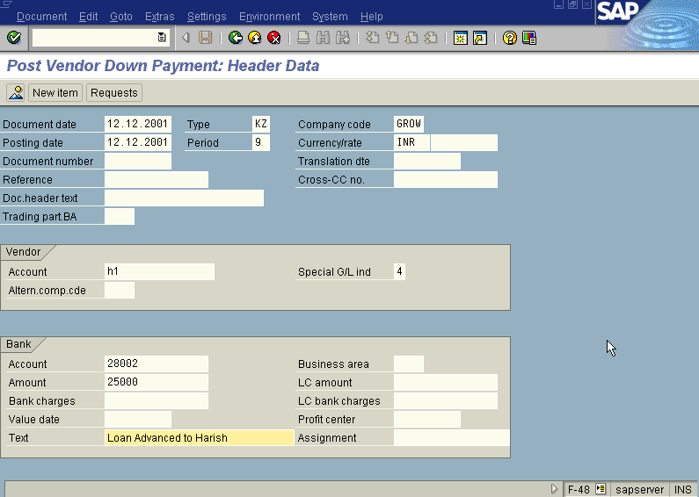

Press Enter button

Now we get the screen “ Post Vendor Down payment – Add Vendor Item” .

In this screen fill three fields
- Amount
- Text

Press Enter button

We will be presented with “ Post Vendor Down payment – Correct Vendor Item”
Screen.

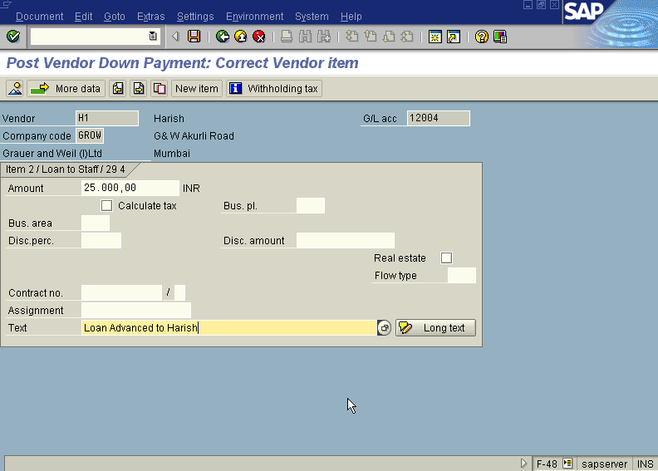
The screen will appear as under.

Press Enter button

Press Save button

The system will display a message as under

Take a note of the document number ; 1500225.

The document can be seen from Document Display from the top left hand side of the main screen “post Vendor down payment - Header Data“ OR from Transaction code FB- 03 .The Document overview screen will be displayed as under showing the entries.

